**Distributed Event Management System**

**Prepared By**: Himen Sidhpura (40091993) & Jenny Mistry (40092281)

**Overall Description:**

Event management is implemented as a distributed system to book and manage events across different branches of a corporate event management company. The system is published using Web Service and the users can see a single system handling user requests providing location and language transparency. It also manages simultaneous requests with adequate synchronization with the help of multithreading.

**Design Architecture:**

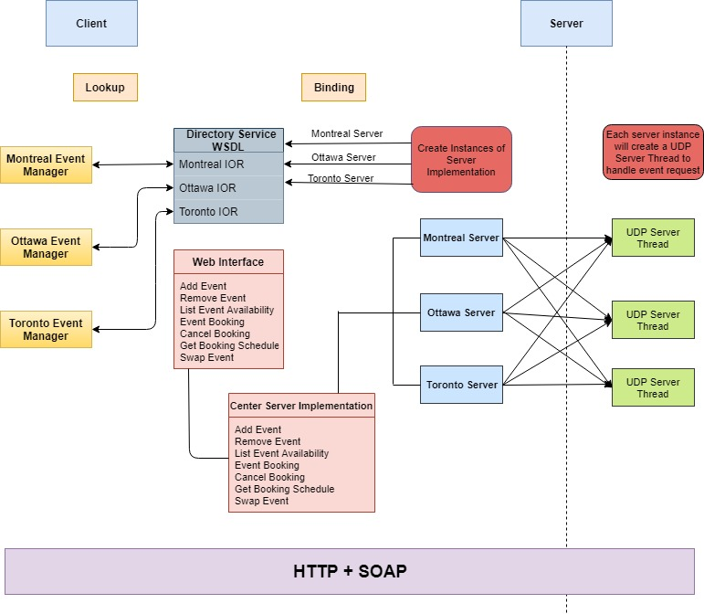

**Web Service Interface:**

* String addEvent(String managerId, String eventId, String eventType, String eventCapacity)
* String removeEvent(String managerId, String eventId, String eventType)
* String listEventAvailability(String managerId, String eventType)
* String eventBooking(String customerId, String eventId, String eventType)
* String cancelBooking(String customerId, String eventId, String eventType)
* String getBookingSchedule(String customerId)
* String swapEvent(String customerID, String newEventID, String newEventType, String oldEventID, String oldEventType)

**Web Service Implementation (EventManagerClient):**

* This class implements the Web interface.
* Three instances of Web Service implementation are created. One each for branches: MTL, OTW, TOR.

**Web Service Directory Service:**

Instances of EventManagerClient is published on localhost with three different strings to expose the WSDL objects to the client.

* Endpoint.publish("http://localhost:8080/EMS/TOR",toronto);
* Endpoint.publish("http://localhost:8080/EMS/MTL",montreal);
* Endpoint.publish("http://localhost:8080/EMS/OTW", ottawa);

**Data Models:**

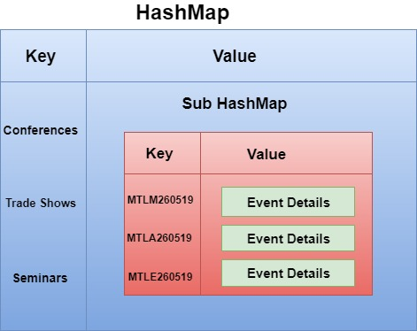

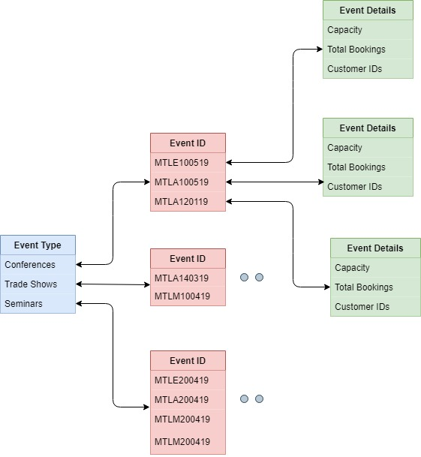

**Logs:**

To perform logging for troubleshooting on both server and client end, we have utilized the logger functionality of Java (java.util.logging).

**Log Format:**

Each log data comprises of the below mentioned details:

* Date and time the request was sent.
* Request type (book an event, cancel an event, etc.).
* Request parameters (clientID, eventID, etc.).
* Request successfully completed/failed.
* Server response for the particular request.

**Center Server:**

Each server log (Montreal, Ottawa, Toronto) will be saved in their respective folder

* logs/MTL.txt
* logs/OTW.txt
* logs/TOR.txt

These logs include:

* Event added
* Event cancelled
* Availability of events
* Events swapped

**Client:**

For every action performed by the client, a log file with clientID is created such as:

* Booking an event
* Canceling an event
* Retrieving booking schedule

**Implementation:**

* We have created a separate logger file for each of the three servers.
* To save contents of the corresponding log file, we have used a file handler.
* Various server responses are recorded using levels like WARNING, ERROR etc.

**UDP Server Design:**

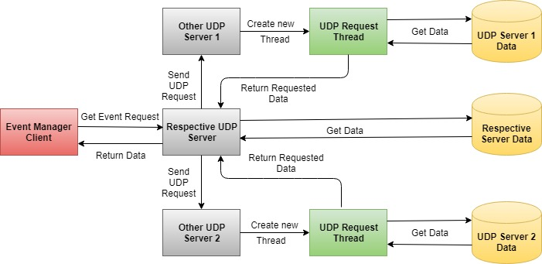

**Flow:**

* The event manager client sends event request to the respective server.
* The server fetches the requested data.
* It forks new requests to send the event request to the other servers located at various locations.
* The UDP servers at these locations receives the request and creates new threads to process the request.
* The newly created threads fetches the respective data and responds to the request.
* The server which received the request responds to the manager client with appropriate data.

**Concurrency:**

The manager client creates new thread to communicate to each of servers to handle requests for same or different events at the same time.

**Code Structure:**

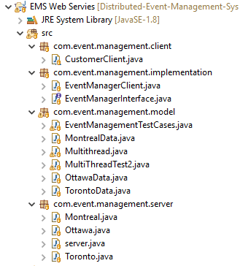

**Challenges:**

Implementation of synchronization while managing multiple event requests at the same time has been challenging.

**Test Scenarios:**

* If the availability of an event is full, more customers cannot book the event.
* A customer can book as many events in his/her own city, but only at most 3 events from other cities overall in a month.
* A customer can perform only customer operation and cannot perform any event manager operation but an event manager can perform all operations for its own branches.
* If the user tries to add an event with an event id already added, then event details get updated.
* The user gets an error message “No events available”, if he/she tries to add an event which is not created by manager.
* All the user and manager event requests have been synchronized to handle multiple concurrent event requests for the same/different branches.
* The swap event is successful only if old event remove and new event add operation are successful.
* If old/new event does not exist for swap event, an error message is shown.
* The swap event throws an error if new event add operation exceeds the month’s max limit.

**References:**

* <https://www.geeksforgeeks.org/multithreading-in-java/>
* <https://docs.oracle.com/javaee/5/tutorial/doc/bnayn.html>
* <https://docs.oracle.com/cd/E17802_01/webservices/webservices/reference/tutorials/wsit/doc/Examples_glassfish4.html>
* <https://www.journaldev.com/9191/java-web-services-tutorial>
* <https://www.theserverside.com/video/Step-by-step-SOAP-web-services-example-in-Java-using-Eclipse>
* <https://stackoverflow.com/questions/14451322/how-to-publish-wsdl-for-java/14451776#14451776>